Exoplanet Name: ________________

Prelab 8: Atmospheric Retention
Due Friday, November 2 at 5pm
Must be submitted by Moodle as a SINGLE word document or PDF. If you fill it out by hand, you must scan or photograph the document and create a single PDF file to submit. If you fill it out electronically, please use a different color or bold your text.

Please write legibly or type your answers. Illegibile assignments will not be graded

This homework requires a set of simulations designed to help you understand some of the basics of gravitational escape from a planet and gas dynamics, both of which will be relevant as we discuss planet atmospheres in the coming weeks. The simulators can all be found at the webpage: http://astro.unl.edu/naap/atmosphere/atmosphere.html. Use the background information and simulators that you find there to answer the following questions.

Background Information
Read/Work through the background sections on Escape Velocity, Projectile Simulation, and Speed Distribution on the website. Then complete the following questions related to the background information.

- Imagine that asteroid A that has an escape velocity of 50 m/s. If asteroid B has twice the mass and twice the radius, it would have an escape velocity ______________ the escape velocity of asteroid A.

Describe your reasoning/show work below.

- Use the Projectile Simulator to determine the escape velocities for various planets and fill them in in the third column of the table on the next page. Do this by setting the masses and radius equal to the values in the table and then manipulating the velocity in the simulator until you see the projectile escape the planet’s gravity. You are looking for the point when a small increase in the velocity results in a different trajectory. The escape velocity is the lowest value where the projectile will continue forever without being pulled back down to the planet, so wait at least 30 seconds after setting the value to see if the projectile turns around and crashes back to the planet.

Object | Mass  (Mearth) | Radius  (Rearth) | vesc  (km/s)
Mercury | 0.055 | 0.38
Uranus | 15 | 4.0
Io | 0.015 | 0.30
Vesta | 0.00005 | 0.083
Krypton | 100 | 10

- After you have used the simulator to estimate the escape velocities for yourself, find the formula for escape velocity in the background materials and use it to check your answer. Fill in your calculation in the final column of the table. Show your work and include units.

- Experiment with the Maxwell Distribution Simulator (under the “Speed Distribution” review section). Then:
  - draw a sketch of a typical gas curve below,
  - label both the x-axis and y-axis appropriately,
  - draw in the estimated locations of the most probable velocity vmp and average velocity vavg
  - shade in the region corresponding to the fastest moving 3% of the gas particles.

Gas Retention Simulator
Open the gas retention simulator. Begin by familiarizing yourself with the capabilities of the gas retention simulator through experimentation.

The gas retention simulator provides you with a chamber in which you can place various gases and control the temperature. The dots moving inside this chamber should be thought of as tracers where each represents a large number of gas particles. The walls of the chamber can be configured to be a) impermeable so that they always rebound the gas particles, and b) sufficiently penetrable so that particles that hit the wall with velocity over some threshold can escape. You can also view the distributions of speeds for each gas in relation to the escape velocity in the Distribution Plot panel.

The lower right panel entitled “gases” allows you to add and remove gases in the experimental chamber. The lower left panel is entitled “chamber properties”. In its default mode it has allow escape from chamber unchecked and has a temperature of 300 K. Click start simulation to set the particles in motion in the chamber panel. Note that stop simulation must be clicked to change the temperature or the gases in the simulation.

The upper right panel entitled “distribution plot” allows one to view the Maxwell distribution of the gas as was possible in the background pages. Usage of the draggable cursor is straightforward and allows one to conveniently read off distribution values such as the most probable velocity. The “show distribution” info for selected gases requires that a gas be selected in the gas panel. This functionality anticipates a time when more than one gas will be added to the chamber.

- Use the pull-down menu to add hydrogen to the chamber.

Complete the table at right using the draggable cursor to measure the most probable velocity for hydrogen at each of the given temperatures. Write a short description of the relationship between T and vmp below.
T (K) | vmp (m/s)
300
200
100

- If the simulator allowed the temperature to be reduced to 0 K, what would you guess would be the most probable velocity at this temperature? Why?

- Return the temperature to 300 K. Use the gas panel to add Ammonia and Carbon Dioxide to the chamber.

Complete the table at right using the draggable cursor to measure the most probable velocity at a temperature of 300 K and recording the atomic mass for each gas. Write a short description of the relationship between mass and v_{mp} and the width of the Maxwell distribution.
Gas | Mass (u) | vmp (m/s)
H2
NH3
CO2

- Check the box entitled allow escape from chamber in the chamber properties panel. You should still have an evenly balanced mixture of hydrogen, ammonia, and carbon dioxide. Run each of the simulations specified in the table below for the mixture. Click reset proportions to restore the original gas levels. Write a description of the results similar to the example completed for you.

Run | T (K) | vesc (m/s) | Description of Simulation
1 | 500 | 1500 | H2 is very quickly lost since it only has a mass of 2u and its most probable velocity is greater than the escape velocity, NH3 is slowly lost since it is a medium mass gas (18u) and a significant fraction of its velocity distribution is greater than 1500 m/s, CO2 is unaffected since its most probable velocity is far less than the escape velocity.
2 | 500 | 1000
3 | 500 | 500
4 | 100 | 1500
5 | 100 | 1000
6 | 100 | 500

- Write a summary of the overall results of your experiments. Under what circumstances was a gas likely to be retained? Under what circumstances is a gas likely to escape the chamber?

Gas Retention Plot
This simulator presents an interactive plot summarizing the interplay between escape velocities of large bodies in our solar system and the Maxwell distribution for common gases. The plot has velocity on the y-axis and temperature on the x-axis. Two types of plotting are possible:

A point on the graph represents a large body with that particular escape velocity and outer atmosphere temperature. An active (red) point can be dragged or controlled with sliders. Realize that the escape velocity of a body depends on both the density (or mass) and the radius of an object.

A line on the graph represents 10 times the average velocity (10×vavg) for a particular gas and its variation with temperature. This region is shaded with a unique color for each gas.

If a body has an escape velocity v_{esc} over 10×v_{avg} of a gas, it will certainly retain that gas over time intervals on the order of the age of our solar system.
If v_{esc} is roughly 5 to 9 times v_{avg}, the gas will be partially retained and the color fades into white over this parameter range.
If v_{esc} < 5 v_{avg}, the gas will escape into space quickly.

- Begin experimenting with all boxes unchecked in both the gasses and plot options. Plot the retention curves for the gases hydrogen, helium, ammonia, nitrogen, carbon dioxide, and xenon. Explain the appearance of these curves on the retention plot.

- Check “show gas giants” in the plot options panel. Discuss the capability of our solar system’s gas giants to retain particular gases among those shown.

- Drag the active point to the location (comparable with the escape speed and temperature) of Mercury. The gases hydrogen, helium, methane, ammonia, nitrogen, and carbon dioxide were common in the early solar system. Which of these gases would Mercury be able to retain?

- Most nitrogen atoms have a mass of 14u (hence 28u for N2), but a small percentage of nitrogen atoms have an extra neutron and thus an atomic mass of 15u. (We refer to atoms of the same element but with different masses as isotopes of that element.) Recently, scientists studying isotope data from the Cassini spacecraft have noticed that the ratio of 15u nitrogen to 14u nitrogen is much larger than it is here on earth. Assuming that Titan and the earth originally had the same isotope ratios, explain why the ratios might be different today.

- Other observations by the Cassini probe have confirmed that Titan has a thick atmosphere of nitrogen and methane with a density of about 10 times that of the Earth’s atmosphere. Is this finding completely consistent with Titan’s position on the atmospheric retention plot? Explain. (Make sure that show icy bodies and moons is checked as well as the gasses methane and nitrogen.)

Apply what you’ve learned to the two questions below.

- A sample of methane (16 u) gas at a temperature of 300K is placed in an experimental chamber. The graph below shows the distribution of speeds for particles of the gas.
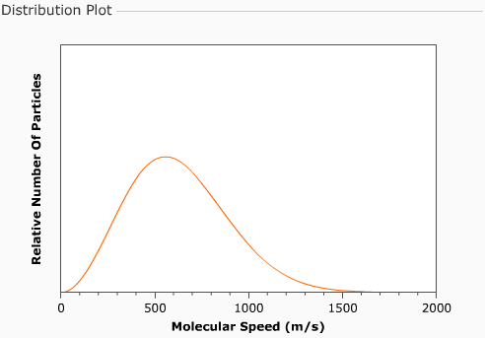

a) Indicate on the plot the most probable velocity with an arrow labeled “most probable velocity” (i.e. the speed at which the most particles are moving) and write in this value next to your arrow.
b) Next estimate the value of the average velocity and show it on the graph with an arrow labeled “average velocity”.
c) Indicate the fastest moving 10% of the particles on the graph with a shaded region.
d) An identical amount of helium (4 u) also at 300K is now added to the chamber. Sketch the speed distribution curve for helium in a different color and label it “helium”.
e) If the walls of the chamber are now configured to allow particles to escape that have a velocity of over 1500 m/s, describe what will happen (i.e. what will the plot look like after time has passed).

f) The chamber once again has the original sample of methane at 300K. Draw in the new speed distribution curve in another color, if the temperature of the methane is lowered to 100K. Label this line “Methane 100K”
16) You can now see a graph of speed (km/s) vs. temperature (K) known as a gas retention plot. Note that speed may represent the escape speed of a planet (a point on the graph) or the average speed of a gas (a curve on the plot).
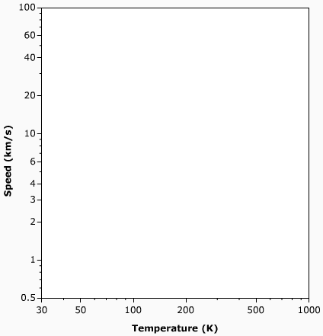
a) The Earth has an escape velocity of 11.2 km/s and an average surface temperature of about 280 K. Indicate the location of the Earth on the plot.

b) Draw in a small region representing where terrestrial planets would be found.

c) Draw in a small region representing where jovian planets would be found.

d) Add the following satellites to the graph:
-- the moon has an escape velocity of 2.4 km/s and a temperature similar to the Earth’s
-- Titan (satellite of Saturn) similar in mass and radius to the moon

Gases are shown on the plot as dashed lines at ten times their average velocity as a function of temperature. Regions on the plot with greater velocities are shown as a solid color. A solar system body can retain a gas over billions of years if its escape velocity is more than ten times the average velocity of the gas. The coloring fades to white at 6 times the average velocity. A solar system body will rapidly loose a gas if its escape velocity is less than 6 times the average velocity.

e) The dashed line on the graph now shows the 10 × vavg curve for hydrogen. Which solar system bodies will clearly be able to retain hydrogen over long periods of time?

f) The 10 × vavg curve for nitrogen is now shown. Which solar system bodies will clearly NOT be able to retain nitrogen over long periods of time?

g) Devise a procedure for using this simulator to determine the minimum size of an asteroid in the main asteroid below that could retain water vapor over long periods of time?

