Homework #11

Part 1: Semester Observing Project Background Section

Type and print or e-mail me:

- 1 paragraph describing the scientific principle(s) behind the phenomenon you observed (why does it happen?).
- A diagram with caption showing the cause or appearance of the phenomenon you observed. This can be hand drawn or obtained from the internet or a textbook.
- 1 paragraph describing the history of observations of the phenomenon you observed

Note that 1 paragraph means 3-4 complete sentences

Part 2: Energy Flow through the Atmosphere and the Greenhouse Effect

Section 1: The solar spectrum
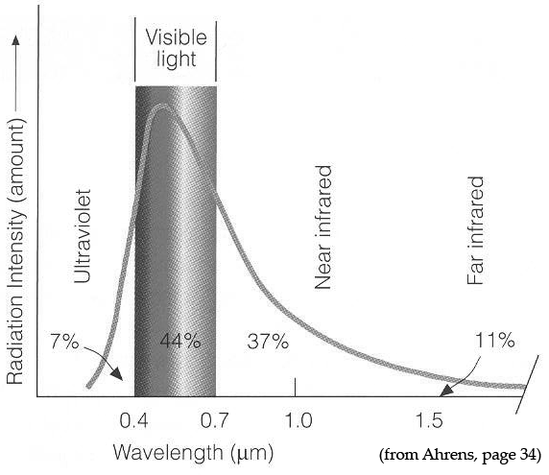
44%
Figure 1
Objects give off different amounts of light depending upon their temperature. Figure 1 below shows the energy spectrum for our Sun along with the percent of energy given off by the Sun in the ultraviolet (UV), visible (VIS), and infrared (IR) portions of the electromagnetic spectrum.

- Which TWO forms of light account for the majority of energy coming from the sun: ultraviolet, visible, or infrared? Which of the three accounts for the least energy? Provide numbers to back up your answer.

- Based upon Figure 1, why is ultraviolet light NOT an important energy source for heating the surface of the Earth?

- Consider the following debate between two students regarding the energy given off by the Sun.

Student #1 – I think that the Sun gives off most of its energy at ultraviolet wavelengths because ultraviolet light is more intense than visible light and you always hear about ultraviolet light causing sunburns.

Student #2 – Even though UV photons are more energetic than visible photons, the Sun simply gives off less ultraviolet photons and gives off way more visible and infrared photons. So I think that these longer wavelength photons account for most of the energy coming from the Sun.

Do you agree and/or disagree with either of these students? Explain your reasoning.

Section #2: Atmospheric absorption of light

Earth’s surface temperature is affected by energy that is absorbed at the surface. However, a photon’s ability to travel through our atmosphere and reach the ground depends upon its wavelength. Figure 2 below shows that certain energies of light are absorbed in our atmosphere more than others. The figure also lists the primary gas molecules responsible for the absorption.
UV
VIS
IR
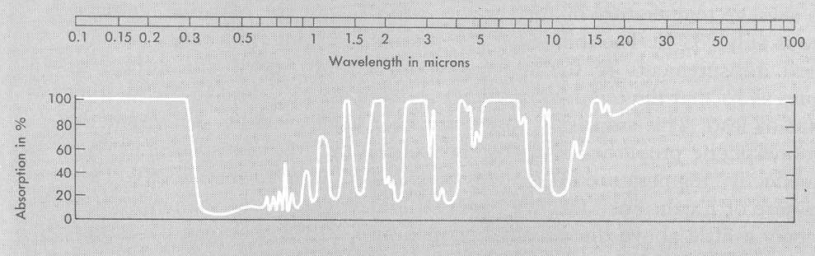
O₂ & O₃ H₂O H₂O CO₂ CO₂ H₂O O₃ CO₂H₂O (rotation)

H₂O

Taken from Goody & Walker, Atmospheres, Prentice-Hall: 1972.

Figure 2

- What gas molecules are primarily responsible for the absorption of each of the following forms of light in our atmosphere?

Type of Light | Molecule(s) Responsible for Absorption
Ultraviolet
Visible
Infrared

- Comparing the visible and the infrared parts of the spectrum, which would you say has an easier time getting through our atmosphere? Which experiences more absorption?

Section 3: Spectrum from Earth’s surface

Once visible light from the Sun reaches the surface of Earth, it can either be reflected back towards space as visible light or be absorbed by the ground. Reflected light does not change the temperature of the surface, while absorbed light causes the temperature of the surface to increase. Ground that is heated then gives off infrared light based upon its increased temperature. As an example, black asphalt absorbs more visible light and gives off more infrared light than a white sidewalk on a hot day.

- The Sun is approximately 6000K at the surface and gives off most of its energy as visible light; the Earth’s surface is much cooler at about 288K. What type of light do you think the Earth’s surface gives off: ultraviolet, visible, or infrared light? Explain your reasoning.

- Does Earth’s surface give off light at night? If so, what type? If not, why not?

- Based upon your answer to Question 5 and 7, will the light given off by Earth’s surface easily travel back through the atmosphere to space or will it be absorbed by molecules in the atmosphere? Explain your reasoning.

Section 4: Energy flow and the greenhouse effect

Figure 3 below shows the flow of energy originally from the Sun through the Earth system (surface and atmosphere). The numbers listed describe the rate of energy flow through system (units of watts per square meter). A larger number indicates that more energy is flowing through that labeled pathway.
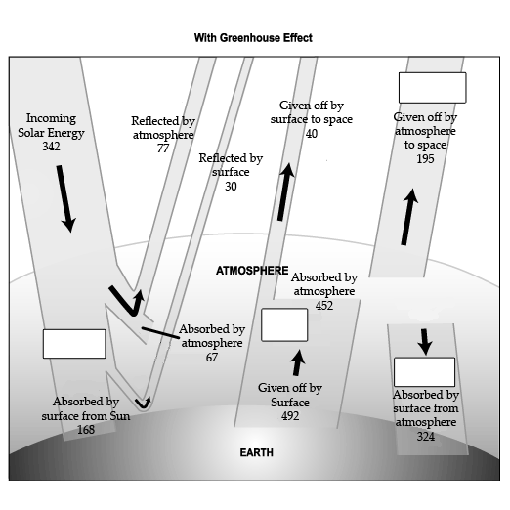
Figure 3

- In Figure 3, fill in the empty boxes with the type of light involved: UV, visible, or IR.

- What two types of light primarily heat Earth’s surface. What one type of light primarily heats Earth’s atmosphere?

- Is more energy absorbed by the Earth’s surface in the form of light from the Sun or light from the atmosphere? Provide values to justify your answer.

- Due to the energy absorbed by Earth’s surface from the atmosphere, is the surface temperature warmer or cooler than it would be without this energy input?

- How does the total rate of energy coming in from space (incoming solar energy) compare to the total rate of energy leaving out to space (all energy reflected or given off by earth and atmosphere)? Provide values to justify your answer.

- Based upon your answer to Question 13, does the total energy in the Earth system increase, decrease, or stay the same over short time scales? Explain your reasoning.

The flow of energy shown in Figure 3 is the source of the natural “atmospheric greenhouse effect.” Visible light penetrates the atmosphere and is absorbed by the surface. The heated surface gives off infrared light that is then absorbed by the atmosphere. The heated atmosphere gives off infrared light out to space and also back down to Earth’s surface, making the surface temperature warmer than it would be without a greenhouse effect. The amount of energy entering and leaving the Earth system is balanced, but the Earth’s surface temperature is warmer because the surface is heated both by visible light from the Sun and infrared light from the atmosphere.

- In Question 4, you listed several gases. Which of these are primarily responsible for absorbing and emitting infrared light? What characteristic makes them greenhouse gases?

- Consider the following debate between three students regarding the greenhouse effect.

Student #1 – So the greenhouse effect is caused by infrared light being trapped in Earth’s atmosphere by greenhouse gases. Visible light from the sun heats the ground, but the infrared light given off by the ground gets permanently trapped in the atmosphere and can never escape.

Student #2 – I think that’s close. But based on Figure 3, all of the arrows balance and just as much energy leaves the planet as comes in. I think the greenhouse effect makes the surface hotter than it would be without greenhouse gases because the ground gets visible light from the Sun AND infrared light from the atmosphere given off back to the surface.

Do you agree and/or disagree with each of these students? Explain your reasoning.

Section 5: Spectrum from Earth’s surface

Once visible light from the Sun reaches the surface of Earth, it can either be reflected back towards space as visible light or be absorbed by the ground. This absorbed visible light causes the temperature of the surface to increase. The ground then gives off energy based upon its increased temperature.

- The surface of the Earth is much cooler than the surface of the sun. In what wavelength region does Earth’s surface give off the most energy?

C
X-ray UV VIS IR Radio
wavelength
long
short
Energy
X-ray UV VIS IR Radio
wavelength
short
Energy
B
X-ray UV VIS IR Radio
wavelength
short
Energy
A
long

long

- Which of the diagrams (A, B, or C) above most accurately represents the energy given off by Earth’s surface as a function of wavelength? Explain your reasoning.

- According to your answers to Questions 17 and 18, would the surface of the Earth give off x-ray, visible, or infrared photons during the middle of the night? Correct your answers to Questions 17 and 18 to match reality if necessary.

- What happen to the temperature of the atmosphere as it absorbs light from either the Sun or from Earth’s surface?

Section 6: The Greenhouse Effect

You should now have a picture of visible light traveling all the way through the atmosphere to the surface of Earth while infrared light (both from the Sun and from Earth’s surface) cannot travel very far through the atmosphere without being absorbed. It is important to note that this absorbed infrared light doesn’t disappear and also isn’t trapped in the atmosphere forever; rather, it simply travels a shorter distance through the atmosphere before it is absorbed and then given off again in a random direction. So, while visible light can travel all the way through the atmosphere without being absorbed, infrared light is continuously absorbed and given off and absorbed and given off many times as it travels through the atmosphere and travels shorter distances.

The diagrams below show possible paths for visible and infrared light as they travel through Earth’s atmosphere. Visible light is represented with dashed arrows; infrared light is shown with solid arrows. Note that three out of the eight diagrams properly depict possible paths for visible and infrared light through the atmosphere.

A
B
C
D
VIS
IR
IR
IR
IR

top of atmosphere
VIS
VIS

IR

Earth’s surface

E
F
G
H

VIS
IR
IR
IR
VIS
VIS
IR

top of atmosphere

IR

Earth’s surface

- List the FIVE diagrams that incorrectly depict how visible and infrared light travel through the atmosphere? For each, describe what is wrong with the diagram.

- Of the remaining three diagrams, which shows visible light reflecting off the surface of the earth and traveling back out to space as visible light? If this light is completely reflected, does it do any heating of the surface?

- In the space below, redraw the TWO diagrams that properly show how visible and infrared light travel through the atmosphere and lead to an enhanced surface temperature.

top of atmosphere
Earth’s surface

What is the source of visible photons that heat the surface of Earth? What are the TWO sources of infrared photons that heat the air in our atmosphere?

- If the surface of Earth immediately gave off to outer space the same amount of energy as it received from the Sun, the surface would be 255K (0°F). Where does the additional energy come from that heats the surface of Earth to its measured value of 288K (58°F)?

