Homework #12: Radial Velocity and Exoplanets
Due in class on Tuesday, November 29 2011

Part A: The Motion of the Sun

Astronomers have made astounding progress in discovering planets orbiting stars outside our solar system. In fact, they have identified a vastly larger number of these planets, called extrasolar planets, than currently exist in our own solar system. There is more than one technique for detecting extrasolar planets. But with current technology, the most effective technique for detection has been the radial velocity of Doppler shift technique. In this activity, you will learn how astronomers use this technique to infer the presence of planets around other stars.

Let’s begin by looking at the radial velocity technique applied to our own solar system. In Figures 1 and 2, there are two different depictions of our solar system. Since the Sun and Jupiter account for nearly all the mass of our solar system, our solar system is modeled here as a two-body problem involving only the Sun and Jupiter. Note that these representations are not drawn to the proper scale for the size or distance of the objects shown.*
Our solar system as seen from above (not to scale)
Our solar system as seen nearly edge-on or from the side (not to scale)
Jupiter

Sun
.
Center of Mass
Jupiter
Sun
.
Center of Mass
Figure 1
Figure 2
*The center of mass of the solar system is located within the Sun. We’ve exaggerated the Sun’s orbit about the center of mass.

- Is Jupiter coming toward or going away from you in Figure 2?

- Is the Sun coming toward or going away from you in Figure 2?

- Draw a stick figure in Figure 1 to indicate where an observer would need to be in relationship to the solar system to see the view shown in Figure 2.

Now examine the four drawings in Figure 3 below. Each of the four drawings shows the positions of the Sun and Jupiter at a different time during a single orbit.

Figure 3

Sun
Jupiter
March 1991
Observer
.
Sun
Jupiter
March 1988
Observer
.
Jupiter
Observer

Sun
March 1994
.

Sun
Jupiter
March 1985
Observer
.

Observer

Observer
- In Figure 3, does the Sun always appear to remain in the same position? If not, describe its motion.
- What form of interaction or force causes the orbital motions of the Sun and Jupiter?

- Estimate the time (in Earth years) for the Sun to complete one orbit (this time is known as the orbital period). How does this time compare to the orbital period of Jupiter?

- For each of the four drawings in Figure 3, use the boxes below to draw what the observer would see at each time period if he or she were observing the solar system nearly edge-on or from the side. See the example in Figure 2.

March 1985
March 1988
March 1991
March 1994

- Make a sketch below (working from the representations in Figure 3) depicting what you would see in September 1992 from the observer location. Your drawings need to include the positions of the Sun and Jupiter.
September 1992

When studying motion it is useful to consider the object’s velocity as being made of two parts or components. The component of velocity that is directed toward (negative) or away from (positive) the observer’s line of sight is known as the radial velocity.

- Imagine that you are at the observer location shown in the drawings you made in Question 8 for September 1992, and that you are located much farther away from the Sun and Jupiter’s orbital paths than is depicted in your drawing.

  - From your point of view and line of sight at the observer location, would the Sun appear to be moving with a radial velocity? If so, is it positive or negative? Explain your reasoning.

  - From your point of view and line of sight at the observer location, does Jupiter appear to be moving with a radial velocity? If so, is it positive or negative? Explain your reasoning.

PART B: RADIAL VELOCITIES OF EXOPLANETS

- Under what condition would you NOT observe a star’s light to ever undergo Doppler shift even when there is an extrasolar planet orbiting the star? Explain your reasoning, and include a drawing to illustrate your answer in the space below.

- Consider the four graphs shown below which show the radial velocity of four stars.
Time (years)
Velocity (m/s)
20
-20
1
3
Time (years)
Velocity (m/s)
20
-20
2
4
Time (years)
Velocity (m/s)
20
-20
3
6
Time (years)
Velocity (m/s)
20
-20
5
10
1
2
3
4
2
4
5
15
20
25
5
8
10
9
12
15

- From which star would you obseve the greatest Doppler Shift? Explain your reasoning.

- Which planet has the longest orbital period? Explain your reasoning.

- Given the location marked with the dot on the star’s radial velocity curve, at what location (1-4) would you expect the planet to be located at this time? Explain your reasoning.

Radial Velocity
1
3
2
4
Earth
Orbit of planet
Orbit of star
10 m/s
20 m/s
Time
-10 m/s
- 20 m/s

Part C: Properties of Extrasolar Planets

Description: The figure below shows the temperature (in Kelvin) at different distances from theSun (in Astronomical Units) in the solar system during the time the planets formed. The tablelists some common temperatures for comparison.
Question 1: Which planets formed at temperatures hotter than the boiling point of water? (2 pts)

Question 2: Which planets formed at temperatures cooler than the freezing point of water?
(2pts)

Question 3: At temperatures hotter than the freezing point of water, light gases, such as
hydrogen and helium, likely had too much energy to condense to form large, gas giant, Jovian planets. Over what range of distances from the Sun would you expect Jovian planets to be able to form? (2 pts)

Question 4: Do you think a large, Jovian planet could have formed at the location of Mercury? Explain your reasoning. (3 pts)

Question 5: How would your answer to Question 3 change if the Sun were an O star? An M star? Explain your reasoning. (3 pts)

Description: The graph below shows the location for the habitable zone (HZ, orange region) for the Sun and other main sequence stars. The HZ is the region around a star where the temperatures are ideal for the existence of liquid water (note that in OUR solar system, this region begins just beyond the orbit of Venus and ends just before the orbit of Mars according to the diagram). The spectral types for different stars (A-M) are shown on the left side of the graph. For reference, the planets of the solar system are shown at their correct distances for the Sun’s mass. Ignore the dashed “tidal lock radius” line.
Question 6: For each spectral type (A, F, G, K, and M) list the planets in our solar system that would reside in the HZ? (5 pts)

Question 7: Extra-solar planets have been found at distances of 0.01 – 0.1 AU around stars of spectral types A, F, G, K, and M. Of the known extra-solar planets, those around which type(s) of stars would be most likely to lie in the HZ? Explain your reasoning. (4pts)

PART D: ANALYSIS OF REAL RV DATA

Now let’s examine actual data gathered by astronomers in their pursuit to find planets orbiting distant stars outside our solar system. Below are the radial velocity versus time graphs for three stars (47 Ursae Majoris, 49 Sengir V Cdc, and HD 11964).* Two of the graphs come from measurements of stars with companion planets; the other is a graph of a star without a companion planet where the variations are either due to noise or some other natural source associated with the star atmosphere. Note that the dots shown in each graph represent the actual measured radial velocities for these stars, and the curves provide a “best fit” to the data points. Use these best fit curves to answer the questions regarding the motion of these three stars.

* The original versions of the real graphs can be found at http://cannon.sfsu.edu/~gmarcy/planetsearch/doppler.html .
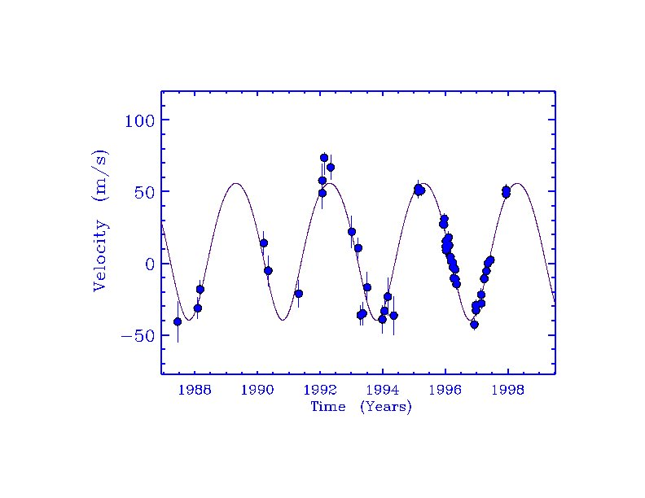
1988 1990 1992 1994
Velocity (m/s)
100
50
0
-50
Time (Years)

Sengir V Cdc
47 Ursae Majoris

50

0

-50

-100

HD 11964

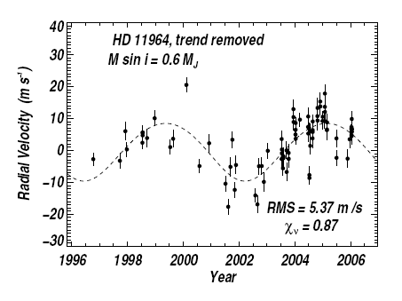
Velocity (m/s)
Time (Years)
- At what time(s) was each star measured to be moving toward Earth with the greatest radial velocity? Note that you are to use a point on the best fit curve in each graph and not the individual data points. How fast was the star moving?

47 Ursae Majoris Sengir V Cdc HD 11964

- For each star, state whether or not you think the star has a companion planet and, if so, estimate the orbital period of the planet. If not, explain why not.

47 Ursae Majoris Sengir V Cdc HD 11964

Part E: Eclipses

For extrasolar planets where the orbit of the planet is such that we see the system edge-on rather than face-on, there is the possibility of seeing the extrasolar planet eclipse its star, dimming it slightly as it passes in front of the star. This has become an important way to learn more about the few dozen systems where eclipses are seen: the amount of the dimming gives the planet size relative to the star.

- Go back to the early part of the activity, pages 1 and 2.

  - Does Figure 1 or Figure 2 show a situation where eclipses are observed?

  - In Figure 3, which date corresponds to an eclipse situation?

  - For the system in Figure 3, how often would eclipses be observed?

- Which of the 3 diagrams below is closest to the situation where a Jupiter-like planet eclipses a Sun-like star? Explain your answer.

(a) (b) (c)

- In the situation above that you think best represents a Jupiter-Sun type of eclipse, by how roughly much (as a percentage) is the star dimmed by the planet? Explain how you got your answer and show your estimate or calculation.

Part F: Pros and Cons of the two Methods

Distant solar systems are oriented at random angles in space; in other words we might be looking at them like in Figure 1 or Figure 2, but most likely it will be some intermediate angle between face-on and edge-on.

- For the Doppler method, which is best orientation for detecting a signal: Figure 1 or Figure 2? If the orientation is in between edge-on and face-on, only a fraction of the full Doppler shift is detected; would we under or over-estimate the mass of the planet? Explain your answers.

- For the eclipse method, which is the best orientation for detecting a signal: Figure 1 or Figure 2? Which figure shows a situation where no eclipse can be detected? Why?

- What is one disadvantage the eclipse method has for detecting planets relative to the Doppler method? (Hint: think about the fraction of time a star is dimmed by an eclipse). What valuable information about the planet is gained by seeing an eclipse?

